**6.Builder Design Pattern:**

YouTube Link: https://www.youtube.com/watch?v=D1CnNAszv_M&list=PLk6CEY9XxSIDZhQURp6d8Sgp-A0yKKDKV&index=6

**Why BDP:**

I want to create an object which is composed of many other complex objects and each have dependency among them.

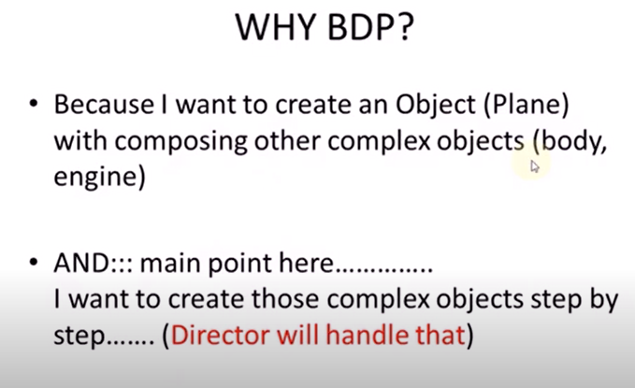

**Question: WHY Builder Design Pattern**

**Answer :** Because I want to build an object(plane) and it is composed of complex

objects (body, engine) step by step.

**More Info:**

https://refactoring.guru/design-patterns/builder